Basic Spreadsheet Concepts - Exercise 1
Type in the following spreadsheet, and format it to look like the sample below.
Instructions
1) Type in all text and numbers shown in the spreadsheet below.
2) Format all numbers as a currency.
3) Center the spreadsheet heading 'Sales for the Month' across the spreadsheet.
4) Format all text as displayed in the sample below.
5) Create formulas to display a total for each sales representative.
6) Create formulas to display a total for each product.
7) Create a formula to calculate the total sales for all sales rep's for the month.

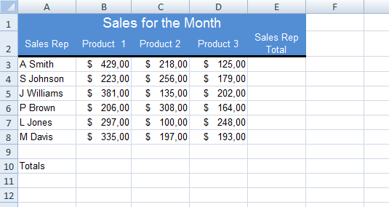

Basic Spreadsheet Concepts - Exercise 2
Type in the following spreadsheet, and format it to look like the sample below.
Instructions
1) Type in all text and numbers shown in the spreadsheet below.
2) Format all numbers with appropriate formats.
3) Center the spreadsheet heading 'Greengrocer’s Order' across the spreadsheet.
4) Format all text as displayed in the sample below, including the rotated text labels.
5) Create formulas to display a total for each fruit item ordered.
6) Create a formula to calculate the total for the greengrocer’s order.

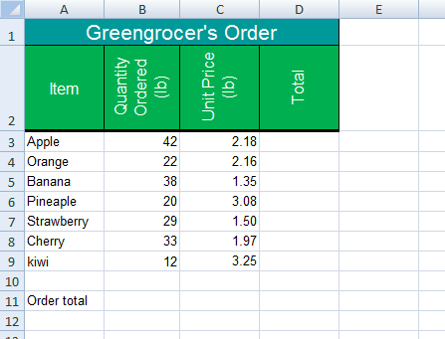
Basic Spreadsheet Concepts - Exercise 3
Type in the following spreadsheet, and format it to look like the sample below.
Instructions
1) Type in all text and numbers shown in the spreadsheet below.
2) Format all numbers with appropriate formats.
3) Center the spreadsheet heading 'Travel Expenses' across the spreadsheet.
4) Format all text as displayed in the sample below, including the rotated text labels.
5) Create formulas to display a total for each Sales Rep.
6) Create formulas to calculate the amount due to each sales rep, on the basis that each rep is reimbursed 0.63 cents per kilometer traveled.
7) Apply all borders and shading (color) shown in the sample below, feel free to experiment with your own color schemes.

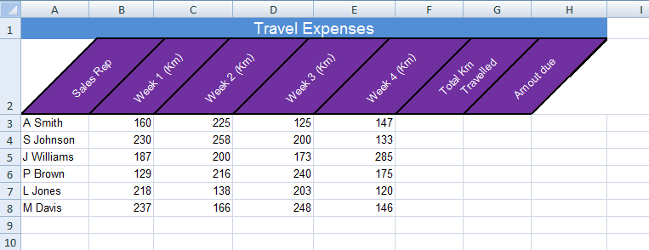

Basic Spreadsheet Concepts - Exercise 4
Type in the following spreadsheet, and format it to look like the sample below.
Instructions
1) Type in all text and numbers shown in the spreadsheet below.
2) Format all numbers with appropriate formats.
3) Center the spreadsheet heading "Lunch Bar" across the spreadsheet.
4) Format all text as displayed in the sample below.
5) Create formulas to display a total for each item in the Lunch Bar.
6) Create a formula to calculate the total sales for the Lunch Bar.
7) Apply all borders and shading (color) shown in the sample below, feel free to experiment with your own color schemes.

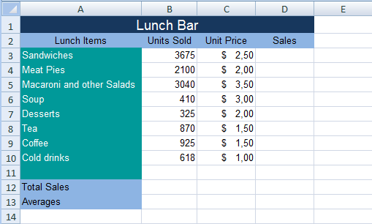
Basic Spreadsheet Concepts - Exercise 5
Type in the following spreadsheet, and format it to look like the sample below.
Instructions
1) Type in all text and numbers shown in the spreadsheet below.
2) Format all numbers with appropriate formats.
3) Center the spreadsheet heading "Weekly Income Schedule" across the spreadsheet.
4) Format all text as displayed in the sample below.
6) Create formulas to calculate the Total Exp (Total Expenditure).
7) Create formulas to calculate the profit.
8) Create formulas to calculate the totals for each column.
9) Apply all borders and shading (color) shown in the sample below, feel free to experiment with your own color schemes.
