Worksheet: Opening an Existing Document, saving and Closing a document

Learning Objective: After this exercise, students will be able to open existing documents, Save documents and close a document.

Opening an Existing Document, saving and Closing a document.

This worksheet requires you complete the activity on “Worksheet: Creating and Opening Documents”

Instructions:

Opening an Existing Document

- Go to File, then click Open and click on the Document you created previously.

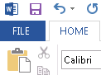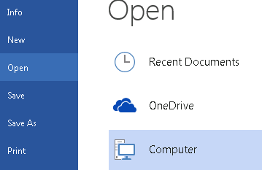

- The Open dialog box appears. Locate and select your document, then click Open.
- Once opened, make an edit to the document by typing the following: I added this sentence today, [Type the date ]

Saving Document

After making an edit to your document, follow the instructions below to Save the file.

- Go to File, and then click on Save.

- If you want to save the File on another document Name, click “Save As”, select the location where you want to save it.
- Type a new File name on the text box below and click on “Save” button below.

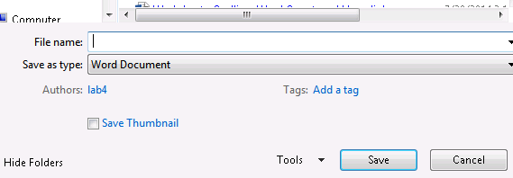

Closing a Document

Once the document is saved, just click the “X” button on the upper right hand corner of the screen.

If the document has not been saved, Microsoft Word will ask you to save the document. Click the Save Botton below and the document will close once saved.

